# Coffins, Shrouds or Urns for Use in the Woodland Burial Ground

Coffins, shrouds or urns for use in the burial ground must consist of biodegradable materials as far as possible. This means that everything to be buried – including the coffin and the clothes worn by the deceased must be biodegradable. Examples of coffin, urn and shroud types are:

## Wood

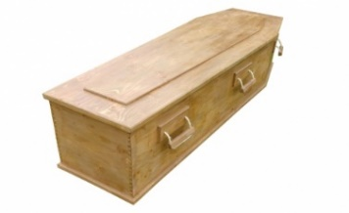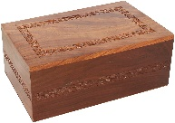

## willow ashes urnWillow CoffinWillow

## Wicker CoffinWicker

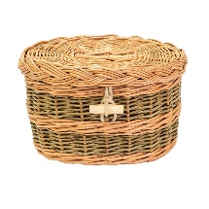

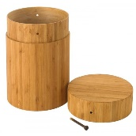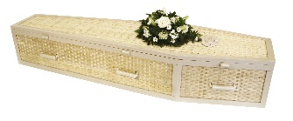Bamboo

## Wool Ashes UrnWoollen CoffinWool

## Banana Leaf Ashes UrnBanana Leaf CoffinBanana Leaf

## Cardboard

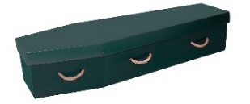

## Sand urns

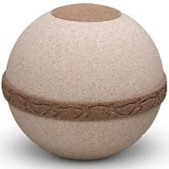

## Cotton or Wool Shrouds

